Entity Relationship model

1. What do you mean by Entity- Relationship Diagram? Explain.  
   Answer: An entity-relationship diagram, or ERD, is a chart that visually represents the relationship between database entities. ERDs model an organization's data storage requirements with three main components: entities, attributes, and relationships.

It is a graphical representation of entities and their relationships to each other, typically used in computing in regard to the organization of data within databases or information systems. An entity is a piece of data-an object or concept about which data is stored. An entity may be defined as a thing capable of an independent existence that can be uniquely identified. An entity is an abstraction from the complexities of a domain. An entity relationship model is used to show how the components of database are communicating with each other.

1. Define entity and give an example.

Answer: An entity may be defined as a thing capable of an independent existence that can be uniquely identified. An entity is an abstraction from the complexities of a domain. Example of entity is person.

1. Explain the different between an entity class and an entity instance.

Answer: "An entity is a person, place, event, or thing about which data is collected...An instance is an occurrence of an entity." An example of this would be CHOCOLATES as the entity while KIT-KAT is an instance of that entity.

If an entity is an individual "person, place, event, or thing about which data is collected", then an entity is an instance. Linguistically, entity is just another word for a single thing. Entities that have the same attributes are grouped in what are best called entity classes. Entity and entity class are data modeling terms. The corresponding object modeling terms are object and class, albeit that a class typically has operations, which are foreign to an entity class.

1. Define attribute and its types.

Answer:  An attribute is a characteristic. In a database management system (DBMS), an attribute refers to a database component, such a table. It also may refer to a database field. Attributes describe the instances in the row of a database.

In Entity Relationship(ER) Model attributes can be classified into the following types.

* Simple and Composite Attribute
* Single Valued and Multi Valued attribute
* Stored and Derived Attributes
* Complex Attribute

1. What is derived attributes?

Answer:  An attribute that’s value is derived from a stored attribute.

Example: Age and its value are derived from the stored attribute Date of Birth.

1. Define relationship and give an example.

Answer: Relationships are represented by diamond-shaped box. Name of the relationship is written inside the diamond-box. All the entities (rectangles) participating in a relationship, are connected to it by a line.

1. Explain the difference between a relationship class and a relationship instance.

Answer: A relationship class is an object in a geo database that stores information about a relationship between two feature classes, between a feature class and a non spatial table, or between two non spatial tables. After two or more entities are identified and defined with attributes, the participants determine if a relationship exists between the entities. A relationship is any association, linkage, or connection between the entities of interest to the business; it is a two-directional, significant association between two entities, or between an entity and itself. Each relationship has a name, an optionality (optional or mandatory), and a degree (how many).

1. Define degree of relationship.

Answer: The degree of relationship is the number of occurrences in one entity which are associated to the number of occurrences in another. There are three degrees of relationship are:

* Binary (2-nry)
* Ternary (3-nry)
* N-nary

1. List and give an example of the three types of binary relationships. Draw an E-R diagram for each.

Answer: The list of types of binary relationships is:

* One-to-one:

When only one instance of an entity is associated with the relationship, it is marked as '1:1'. The following image reflects that only one instance of each entity should be associated with the relationship. It depicts one-to-one relationship.

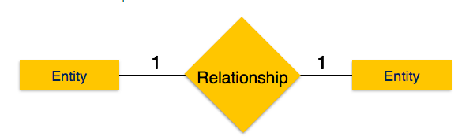

* One-to-many:

When more than one instance of an entity is associated with a relationship, it is marked as '1:N'. The following image reflects that only one instance of entity on the left and more than one instance of an entity on the right can be associated with the relationship. It depicts one-to-many relationship.

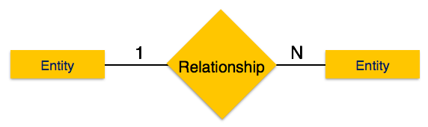

* Many-to-many:

The following image reflects that more than one instance of an entity on the left and more than one instance of an entity on the right can be associated with the relationship. It depicts many-to-many relationship.

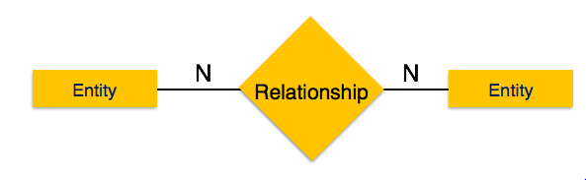

1. Define the terms maximum cardinality and minimum cardinality.

Answer: The maximum number of instances of one entity that may be associated with each instance of another entity is known as **maximum cardinality**. Maximum cardinality indicates how many instances are participating in a relationship. The possibilities include one-to-one (1:1), one-to-many (1:M), or many-to-many (M:N).

The minimum number of instances of one entity that may be associated with each instance of another entity is known as **minimum cardinality**. The minimum cardinality indicates the smallest number of participants in a relationship, which can be 0 or 1 (optional or mandatory). When evaluating minimum cardinality, you should think about what is actually taking place.

1. Explain the distinctions among the terms primary key, candidate key and super key.

Answer: **Super Key:** An attribute or set of attributes that uniquely identifies a tuple within a relation  
  
**Candidate key:** A super key such that no proper subset is a super key within the relation  
  
**Primary key:** The candidate key that is selected to identify tuples uniquely within the relation, the candidate keys which are not selected as PKs are called "Alternate keys"

1. What are the main building modules of the entity relationship model? Discuss each one.

Answer:

1. What is composite attributes, when it is used?

Answer:

1. Explain the difference between single-value attributes and simple attributes.

Answer:

1. Discuss the difference between a composite key and a composite attribute. How would each indicate in an E-R diagram?

Answer:

1. What two courses of action are available to a designer when a multivalued attribute is encountered?

Answer:

1. Explain the various terms of an E-R model and how are they represented in an E-R model?

Answer:

18. Explain the concept of dependent entities? Give example.

19. What is the difference total and partial participation? Explain.

20. What do you mean by mapping cardinalities ? explain various type of cardinalities.

21. What is the difference between single-value and multivalued attributes? Explain

22. Explain the concept of participation constraints.

23. Difference the binary relationship with ternary relationship with example.

24. Explain the difference between weak and strong entity set.

25. Define the components of extended E-R features.

26. Define the concept of aggregation. Give two examples of where this concept is useful.

27. Explain the distinction between disjoint and overlapping constraints.

28. Explain the distinction between total and partial constraints.

29. Write short notes on:

· Specialization

· Generalization

· Aggregation